**ANALYZE AND VISUALIZE SWIGGY FOOD DELIVERY FOR DIFFERENT CUISINES**

**INT 200 – INTERNSHIP PROECT REPORT**

**TERM IV (Year 1)**

***Submitted by***

**Ruthvika Muchala - E0121036**

***In partial fulfilment for the award of the degree of***

**BACHELOR OF TECHNOLOGY**

**in**

**COMPUTER SCIENCE AND ENGINEERING**

**(Artificial Intelligence & Data Analytics)**

**Sri Ramachandra Engineering and Technology**

**Sri Ramachandra Institute of Higher Education and Research, Porur, Chennai -600116**

**JULY 2022**

**ANALYZE AND VISUALIZE SWIGGY FOOD DELIVERY FOR DIFFERENT CUISINES**

**INT 200 – INTERNSHIP PROECT REPORT**

**TERM IV (Year 1)**

***Submitted by***

**Ruthvika Muchala - E0121036**

***In partial fulfilment for the award of the degree of***

**BACHELOR OF TECHNOLOGY**

**in**

**COMPUTER SCIENCE AND ENGINEERING**

**(Artificial Intelligence & Data Analytics)**

**Sri Ramachandra Engineering and Technology**

**Sri Ramachandra Institute of Higher Education and Research, Porur, Chennai -600116**

**JULY 2022**

**BONAFIDE CERTIFICATE**

Certified that this project report “**Analyse and Visualize Food Delivery for Different Cuisines**” is the bonafide work of **Ruthvika Muchala Reg No. E0121036** who carried out the internship work under my supervision.

**Signature of Faculty Mentor Signature of Vice-Principal**

|  |  |
| --- | --- |
| **C. Santhiya**  Lecturer,  Department of Computer Science and Engineering,  Sri Ramachandra Faculty of Engineering and Technology,  SRIHER, Porur, Chennai-600116. | **Prof. M. Prema**  Vice-Principal,  Department of Computer Science and Engineering,  Sri Ramachandra Faculty of Engineering and Technology,  SRIHER, Porur, Chennai-600116. |

**Evaluation Date:**

**ACKNOWLEDGEMENT**

I express my sincere gratitude to our Chancellor, Vice-Chancellor and our sincere gratitude to our Provost **Dr. Raju** and our Vice-Principal **Prof. Prema** for their support and for providing the required facilities for carrying out this study.

I wish to thank my faculty supervisor, **Prof. Santhiya,** Department of Computer Science and Engineering, Sri Ramachandra Faculty of Engineering and Technology for extending help and encouragement throughout the project. Without her continuous guidance and persistent help, this project would not have been a success for me.

I am grateful to Department of Computer Science and Engineering, Sri Ramachandra Engineering and Technology, our beloved parents, and friends for extending the support, who helped us to overcome obstacles in the study.

**TABLE OF CONTENTS**

**Title** **Page**

1. INTRODUCTION 6
   1. Data Analysis 6
   2. Data Visualization 6
2. OBJECTIVE 7
3. WORKFLOW 8

3.1 Project Workflow 8

1. TECHNOLOGY USED 9-10
   1. Tableau 9
   2. Angular 9
   3. Visual Studio Code 10
   4. Bootstrap 10
2. IMPLEMENTATION 11

5.1 Tableau graphs and questionnaires 12-16

1. SAMPLE CODE AND OUTPUT 17-36
   1. Code 17-30
   2. Output 31-36
2. TROUBLESHOOTING PHOTO 37
3. CONCLUSION 38
4. FUTURE SCOPE 39

REFERENCES 40

APPENDICES 41

Work Log 41

Certificate of Completion 42

**CHAPTER-1**

**INTRODUCTION**

**1.1 Data analysis:**

Data analysis is a process of inspecting, cleansing, transforming, and modelling data with the goal of discovering useful information, informing conclusions, and supporting decision-making. Data analysis has multiple facets and approaches, encompassing diverse techniques under a variety of names, and is used in different business, science, and social science domains. In today's business world, data analysis plays a role in making decisions more scientific and helping businesses operate more effectively.

**1.2 Data visualization:**

Data visualization is the representation of data through use of common graphics, such as charts, plots, infographics, and even animations. These visual displays of information communicate complex data relationships and data-driven insights in a way that is easy to understand. It helps in presenting billions of data points into meaningful insights. It is a very important tool for all data scientists to learn and understand the data in more detail. Visualization also helps business leaders to take important decisions for company growth and to move in the right direction.

**CHAPTER-2**

**OBJECTIVE**

We often order food from food delivery apps like Swiggy. Sometimes it often takes time to deliver the food. There are factors that impact the delivery time of the food.

In this, we are going to work on a data visualization challenge to analyse and visualize the food delivery time from the same location but different cuisines and ratings of the restaurants.

An accurate time estimation not only results in better customer experience but can also reduce the burden on our customer support teams.

Hence, the main aim of this project is to visually analyse the various factors involved in delivery of food to the customer for different cuisines with using Tableau specifically analyses the above information for Swiggy Food Delivery app.

**CHAPTER-3**

**3.1 Project Workflow**

Research

Learning

Tableau

Data

Entry

Data

collection

Web development

Data

Analysis

Figure 3.1 – Food Delivery Process Flow

**CHAPTER-4**

**TECHNOLOGY USED**

**4.1 Tableau:**

Tableau is a data visualization software designed to query cloud databases, spreadsheets, machine learning algorithms, social databases, and other database advancements to create simple oriented graph-like data visualizations.

**4.2 Angular:**

Angular is a TypeScript-based open-source web application framework led by the Angular Team at Google and by a community of individuals and corporations. Angular is a complete rewrite from the same team that built AngularJS

**4.3 Visual Studio Code:**

It is an editor redefined and optimized for building and debugging modern applications. It supports hundreds of languages. Visual Studio Code, also commonly referred to as VS Code, is a source-code editor made by Microsoft for Windows, Linux and macOS. Features include support for debugging, syntax highlighting, intelligent code completion, snippets, code refactoring, and embedded Git.

**4.3 Bootstrap:**

Bootstrap is a potent front-end framework used to create modern websites and web apps. It's open-source and free to use and yet features numerous HTML and CSS templates for UI interface elements such as buttons and forms. Bootstrap also supports JavaScript extensions.

**CHAPTER-5**

**IMPLEMENTATION**

* First, the column names for the data set were decided and created in Microsoft excel.
* Then, data was collected from the past order history in the Swiggy app. This data was collected from different places or states in India.
* After the completion of the data set, it was normalized to avoid the repetition of data.
* Questionnaires were created by each group member based on the data collected.
* The final data set was then uploaded to the Tableau software to visualize the data in various forms, hence answering the above created questionnaires.
* An interactive website was created with Angular and bootstrap using the above data which enabled us to display all questionnaires, answers, cuisines, data collected and more.

**5.1 Tableau graphs and questionnaires**

1. Which cuisine got very good delivery rating with best food rating from the customers ?

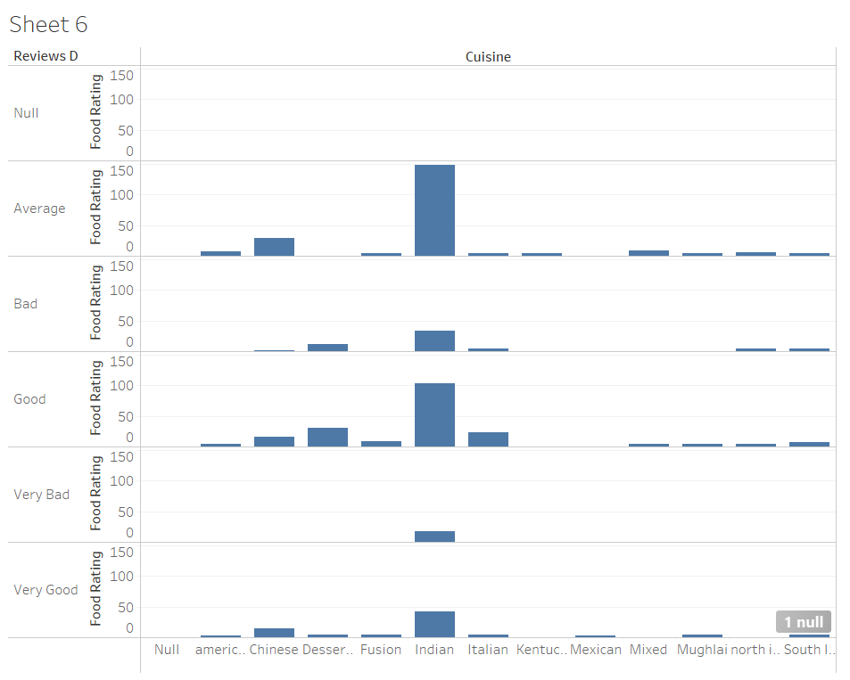

1. Interpret the following graph which place got the best delivery rating and took less delivery fee ?

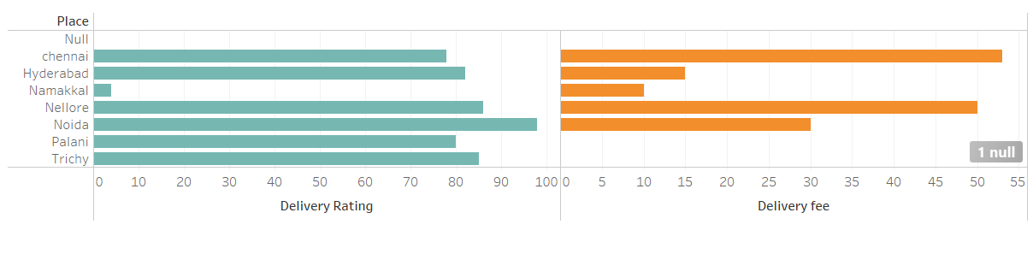

1. How much does it costs for packaging charges in Chennai to deliver a Indian cuisine ?

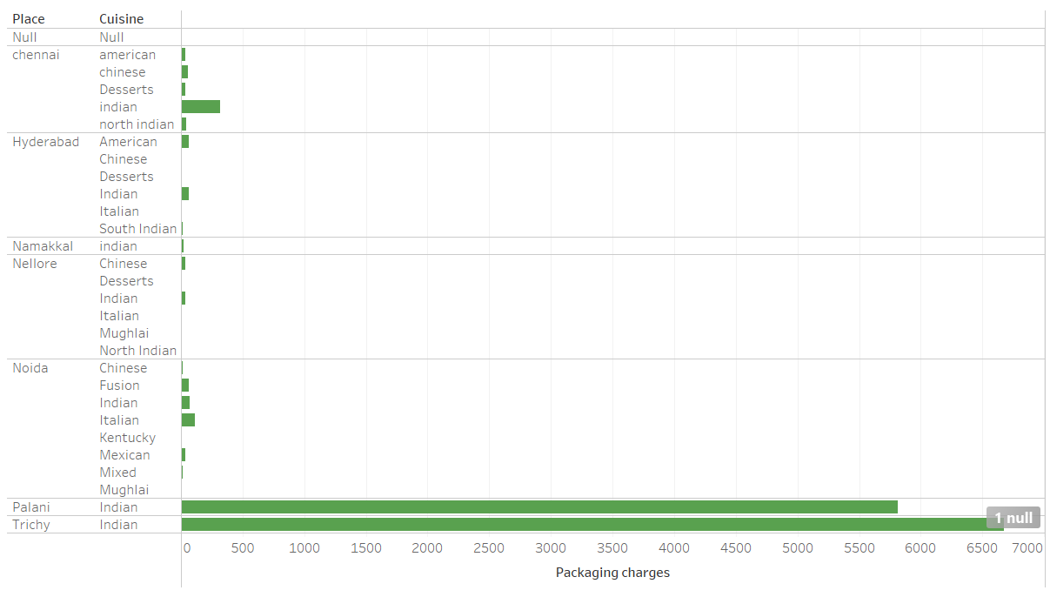

1. Estimate the average time taken to deliver a Chinese cuisine in total dataset collected ?

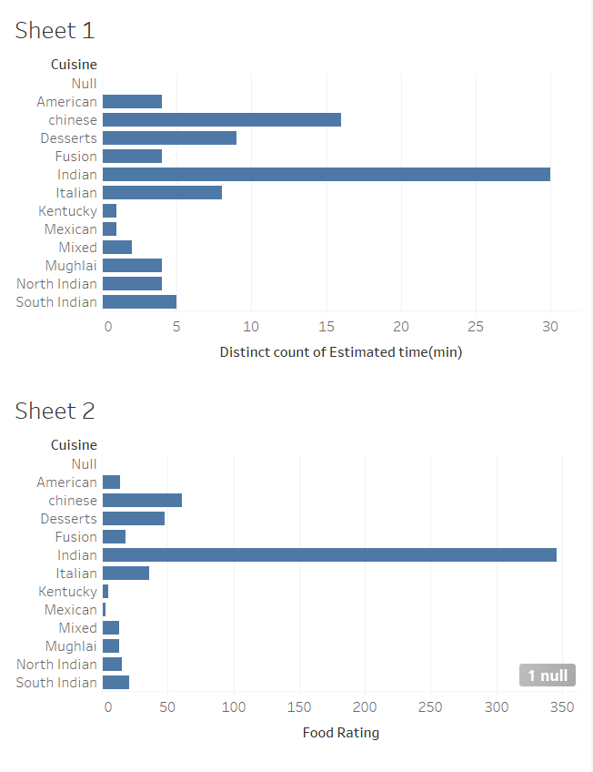

1. Which place got least delivery fee compared to other places in data collected ?

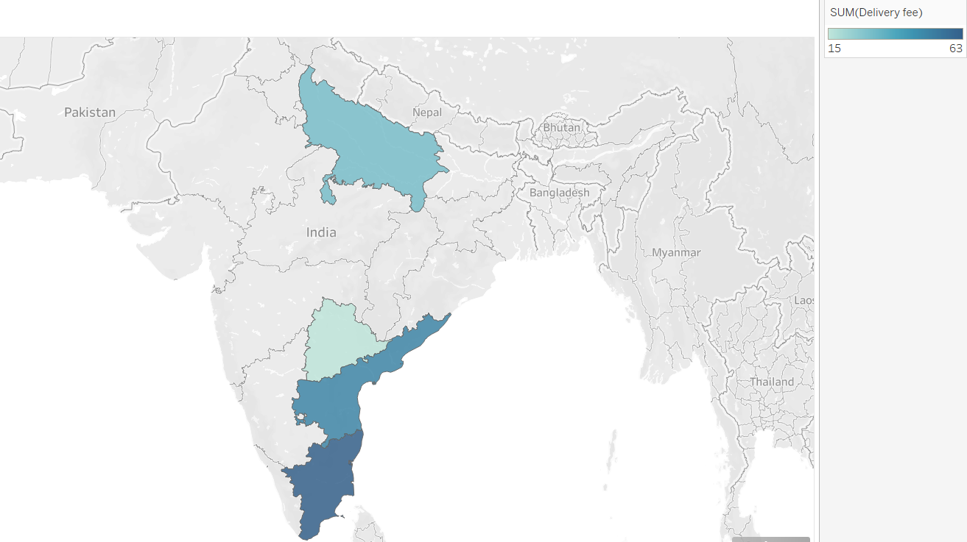

1. In Nellore which Cuisine has the highest food rating in the dataset ?

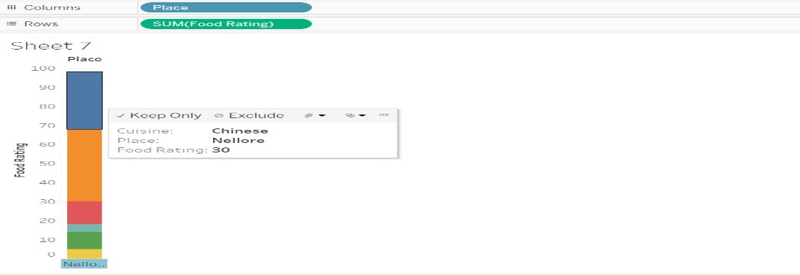

1. In Nellore which Restaurant had the highest delivery rating in the dataset ?

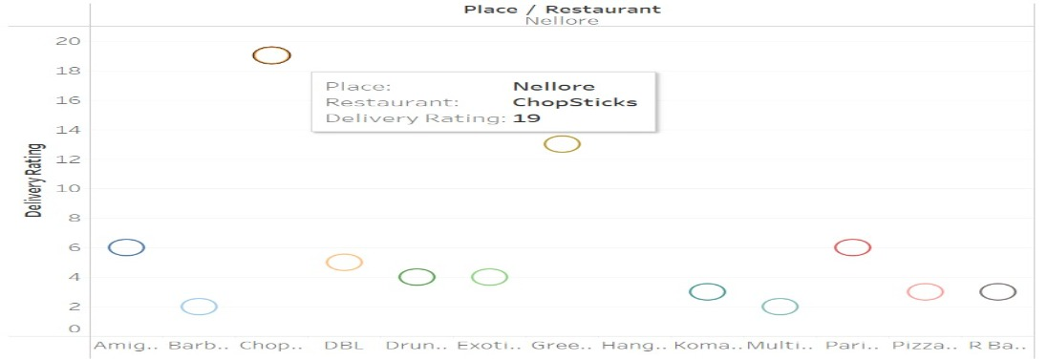

1. InNellore which mode of paymentis used comparatively less in the dataset ?

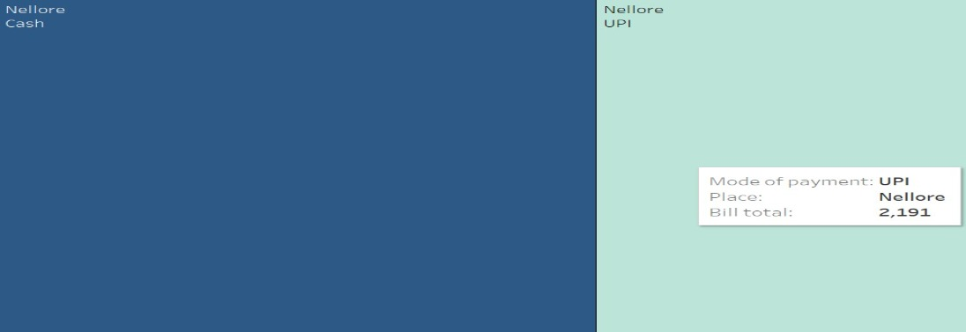

1. In Nellore which item has the highest tax amount in the dataset ?

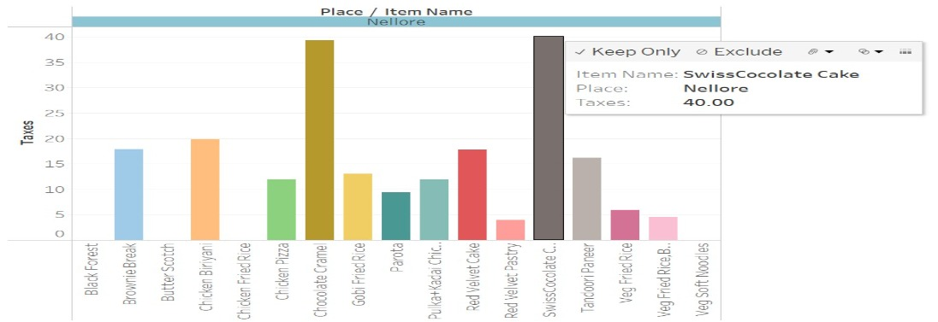

1. In Nellore which Restaurant has the highest bill amount in the dataset ?

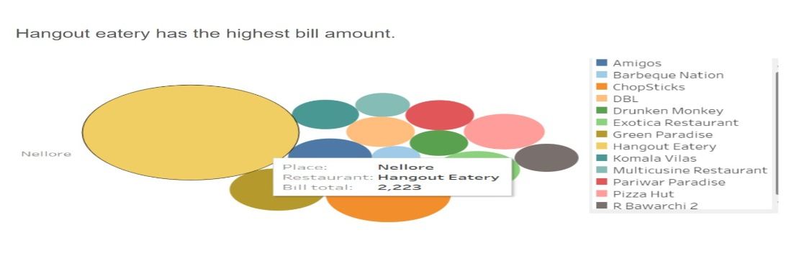

**CHAPTER-6**

**SAMPLE CODE AND OUTPUT**

**6.1 Code:**

app.component.html

<div class="container-fluid" style="height: 840px">

  <div class="row">

    <div

      class="col-sm-1"

      style="height: 100px; background-color:rgb(135, 113, 144)"

    >

      <app-logo></app-logo>

    </div>

    <div

      class="col-sm-11"

      style="height: 100px; background-color: rgb(135, 113, 144)"

    >

      <app-title></app-title>

    </div>

  </div>

  <div class="row">

    <div

      class="col-sm-12"

      style="height: 50px; background-color: rgb(135, 113, 144)"

    >

      <app-navbar></app-navbar>

    </div>

  </div>

  <div class="row">

    <div

      class="col-sm-3"

      style="height: 550px; background-color:rgb(170, 131, 160)" >

      <router-outlet name="navbar"></router-outlet>

    </div>

    <div

      class="col-sm-9"

      style="height: 550px; background-color:  rgb(172, 154, 179)"

    >

      <router-outlet name="maincontent"></router-outlet>

    </div>

  </div>

  <div class="row">

    <div

      class="col-sm-4"

      style="height: 140px; background-color: rgb(157, 118, 153)">

      <h4>Team Members :</h4>

      <h5>👧 Ruthvika Muchala</h5>

      <h5>👧 Anne Asritha</h5>

      <h5>👧 Sivane senthil</h5>

    </div>

    <div

      class="col-sm-4"

      style="height: 140px; background-color: rgb(157, 118, 153)">

      <h4>Team Members :</h4>

      <h5>👧 Diya Dinesh</h5>

      <h5>👦 Kishor Kumar</h5>

      <h5>👦 Keshav Krishna</h5>

    </div>

    <div

      class="col-sm-4"

      style="height: 140px; background-color: rgb(157, 118, 153)">

      <h4>Project Mentor :</h4>

      <h5>👩‍🦰 Prof.Santhiya</h5>

    </div>

  </div>

</div>

app.module.ts

const routes: Routes = [

  {

    path:'data',

    component:DataComponent,

    outlet:'navbar',

  },

  {

    path:'data/view',

    component:ViewComponent,

    outlet:'maincontent'

  },

  {path:'tableau',component:TableauComponent,outlet:'navbar'},

  {path:'tableau/viewt',component:ViewtComponent,outlet:'maincontent'},

  {path:'places',component:PlacesComponent,outlet:'navbar'},

  {path:'places/andhra',component:AndhraComponent,outlet:'maincontent'},

  {path:'places/tamil',component:TamilComponent,outlet:'maincontent'},

  {path:'places/telengana',component:TelenganaComponent,outlet:'maincontent'},

  {path:'places/up',component:UpComponent,outlet:'maincontent'},

  {path:'cuisines',component:CuisinesComponent,outlet:'navbar'},

  {path:'cuisines/desserts',component:DessertsComponent,outlet:'maincontent'},

  {path:'cuisines/north',component:NorthComponent,outlet:'maincontent'},

  {path:'cuisines/south',component:SouthComponent,outlet:'maincontent'},

  {path:'cuisines/chinese',component:ChineseComponent,outlet:'maincontent'},

  {path:'cuisines/continental',component:ContinentalComponent,outlet:'maincontent'},

  {path:'cuisines/drinks',component:DrinksComponent,outlet:'maincontent'},

  {path:'cuisines/biriyani',component:BiriyaniComponent,outlet:'maincontent'},

  {path:'question',component:QuestionComponent,outlet:'navbar'},

  {path:'question/viewq',component:ViewqComponent,outlet:'maincontent'},

];

styles.css

@import "./bootstrap.css"

logo.component.html

<img src="../assets/c.png"  style="width:110px; height:100px;border-radius:20%">

navbar.component.html

<ul class="list">

    <a [routerLink]="['/', { outlets: { navbar: ['data'], maincontent: [] } }]"

      >Data Collected</a

    >

    <a [routerLink]="['/', { outlets: { navbar: ['tableau'], maincontent: [] } }]"

      >Tableau</a

    >

    <a [routerLink]="['/', { outlets: { navbar: ['places'], maincontent: [] } }]"

      >Places</a

    >

    <a

      [routerLink]="['/', { outlets: { navbar: ['cuisines'], maincontent: [] } }]"

      >Cuisines</a

    >

    <a

      [routerLink]="[

        '/',

        { outlets: { navbar: ['question'], maincontent: [] } }

      ]"

      >Questionnaire</a

    >

  </ul>

navbar.component.css

.list{

    text-align: centre;

    justify-content: space-around;

}

.list a{

   font-weight:bold;

    float: left;

    text-decoration: none;

    font-size: 25px;

    color: white;

    transition: 0.4s;

    text-align: center;

    padding-right:110px;

    padding-left: 45px;

    padding-bottom: 100px;

}

.list a:hover{

    color: rgb(65, 65, 64);

}

cuisines.component.html

<ul class="list">

    <a [routerLink]="['', { outlets: { maincontent: ['cuisines', 'desserts'] } }]">Desserts </a>

    <a [routerLink]="['', { outlets: { maincontent: ['cuisines', 'north'] } }]">North Indian </a>

    <a [routerLink]="['', { outlets: { maincontent: ['cuisines', 'south'] } }]">South Indian </a>

    <a [routerLink]="['', { outlets: { maincontent: ['cuisines', 'chinese'] } }]">Chinese </a>

    <a [routerLink]="['', { outlets: { maincontent: ['cuisines', 'biriyani'] } }]">Biriyani</a>

    <a [routerLink]="['', { outlets: { maincontent: ['cuisines', 'continental'] } }]">Continental </a>

    <a [routerLink]="['', { outlets: { maincontent: ['cuisines', 'drinks'] } }]">Drinks </a>

  </ul>

cuisines.component.css

list{

    text-align: centre;

    justify-content: space-around;

}

.list a{

   font-weight:bold;

    float: left;

    text-decoration: none;

    font-size: 25px;

    color: rgb(50, 8, 8);

    transition: 0.4s;

    text-align:center;

    padding-right:80px ;

padding-left: 10px;

padding-bottom: 30px;

padding-top: 10px;

}

.list a:hover{

    color: rgb(250, 234, 234);

}

chinese.component.html

<div class="product">

    <!--product-box-container-->

    <div class="product-container">

        <!--box-->

        <div class="p-box">

            <!--image 1-->

            <img src="../assets/e1.jpeg">

            <div class="item-name">

            <!--Details-->

            <p><b>Noodles</b></p>

            </div>

        </div>

        <div class="p-box">

            <!--image 2-->

            <img src="./assets/e2.jpeg" alt=""/>

            <!--Details-->

            <p><b>Fried Rice</b></p>

        </div>

        <div class="p-box">

            <!--image 3-->

            <img src="../assets/e3.jpeg" alt=""/>

            <!--Details-->

            <p><b>Chicken Lollipop</b></p>

        </div>

        <div class="p-box">

            <!--image 4-->

            <img src="../assets/e4.jpeg" alt=""/>

            <!--Details-->

            <p><b>Manchuria</b></p>

        </div>

        <div class="p-box">

            <!--image 5-->

            <img src="../assets/e5.jpeg" alt=""/>

            <!--Details-->

            <p><b>Momos</b></p>

        </div>

        <div class="p-box">

            <!--image 6-->

            <img src="../assets/e6.jpeg" alt=""/>

            <!--Details-->

            <p><b>Chilli Chicken</b></p>

        </div>

    </div>

</div>

chinese.component.css

.product{

    left: -60px;

    float: right;

    width: 85%;

    display:flex;

    margin: 30px auto;

    flex-direction: column;

    align-items:center;

    padding: 80px 1px;

    margin-top: -38px;

    position:relative;

    background-size: 1000px;

    background-position:center;

    border-radius: 10px;

}

.product-container{

   display: flex;

   justify-content: center;

   align-items: wrap;

   flex-wrap: wrap;

   margin: 10px 0px;

   width: 130%;

}

.p-box{

    width: 280px;

    height: 200px;

    justify-content: center;

    align-items: center;

    flex-direction: column;

    border-radius: 4px;

    position: relative;

    margin: 10px 30px;

}

.p-box img{

    height: 160px;

}

.p-box p{

    color: black;

    font-size: 1.2rem;

    letter-spacing:0.5px ;

}

.p-box:hover{

    box-shadow:2px 2px 30px rgba(0,0,0,0.1);

    background-color:#FFFFFF;

    padding-left: 3%;

}

(Similar layout for all other cuisines)

data.component.css

<p>

  ♠️ The data and the data set were obtained from multiple <i>swiggy customers</i>.<br>

  ♠️ The data is organised in a table format using google excel sheets.<br>

  ♠️ The data has specifications of individual users like duration of time that was required for a particular cuisine to be delivered.<br>

  ♠️ Taking the collected data into consideration lets visualise and analyse which cuisine is taking the most time to get delivered based on the region the order is got placed.<br>

  ♠️ Data visualization helps  in presenting billions of data points into meaningful insights. <br>

  ♠️ It is a very important tool for all the data scientists to learn and understand the data in more details. <br>

  ♠️ Visualization also helps business leaders to take important decisions for company growth and to move in the right direction.

</p>

<ul class="list">

  <a [routerLink]="['', { outlets: { maincontent: ['data', 'view'] } }]">View Data Collected</a>

</ul>

data.component.css

list{

    text-align: centre;

    justify-content: space-around;

}

.list a{

   font-weight:bold;

    float: left;

    text-decoration: none;

    font-size: 22px;

    color: rgb(50, 8, 8);

    transition: 0.4s;

    text-align:center;

    padding-right:10px ;

padding-left: 10px;

}

.list a:hover{

    color: rgb(250, 234, 234);

}

view.component.html

<img src="../assets/d.png"  style="width:407px; height:550px;">

<img src="../assets/d.png"  style="width:360px; height:550px;">

<img src="../assets/d.png"  style="width:345px; height:550px;">

places.component.html

<ul class="list">

    <a [routerLink]="['', { outlets: { maincontent: ['places', 'andhra'] } }]">Andhra Pradesh</a>

    <a [routerLink]="['', { outlets: { maincontent: ['places', 'tamil'] } }]">Tamil Nadu</a>

    <a [routerLink]="['', { outlets: { maincontent: ['places', 'telengana'] } }]">Telengana</a>

    <a [routerLink]="['', { outlets: { maincontent: ['places', 'up'] } }]">Uttar Pradesh</a>

  </ul>

places.component.html

list{

    text-align: centre;

    justify-content: space-around;

}

.list a{

   font-weight:bold;

    float: left;

    text-decoration: none;

    font-size: 25px;

    color: rgb(50, 8, 8);

    transition: 0.4s;

    text-align:center;

    padding-right:100px ;

padding-left: 10px;

padding-bottom: 50px;

padding-top: 40px;

}

.list a:hover{

    color: rgb(250, 234, 234);

}

andhra.component.html

<button class="up1Btn "(click)="imageSource = '../../assets/ap1.jpg'" style="width: 10%,height=auto">1.In nellore which cuisine has the highest food rating in the dataset ?</button><br>

<button class="up2Btn" (click)="imageSource = '../../assets/ap2.jpg'" style="width: 10% ,height=auto">2.In Nellore which restaurant had the highest delivery rating in the dataset?</button><br>

<button class="up3Btn" (click)="imageSource = '../../assets/ap3.jpg'" style="width: 10%,height=auto">3.In Nellore which mode of payment is used comparatively less in the dataset?</button><br>

<button class="up4Btn "(click)="imageSource = '../../assets/ap4.jpg'" style="width: 10%,height=auto">4.In Nellore which item has highest tax amount in the dataset?</button><br>

<button class="up5Btn" (click)="imageSource = '../../assets/ap5.jpg'" style="width: 10%,height=auto">5.IN Nellore which restaurant has the highest bill amount in the data set?</button><br>

<div class="img">

    <img [src]="imageSource" *ngIf="imageSource"/>

    </div>

(Similar layout for all other states)

question.component.html

<ul class="list">

    <a [routerLink]="['', { outlets: { maincontent: ['question', 'viewq'] } }]">View Questionnaire Collected</a>

  </ul>

question.component.css

list{

    text-align: centre;

    justify-content: space-around;

}

.list a{

   font-weight:bold;

    float: left;

    text-decoration: none;

    font-size: 22px;

    color: rgb(50, 8, 8);

    transition: 0.4s;

    text-align:center;

}

.list a:hover{

    color: rgb(250, 234, 234);

}

viewq.component.html

<button class="up1Btn "(click)="imageSource = '../../assets/q1.jpg'" style="width: 10%,height=auto">1. In Noida which cuisine got the greatest discount on food?</button><br>

<button class="up2Btn" (click)="imageSource = '../../assets/q2.jpg'" style="width: 10% ,height=auto">2.Which cuisine took  longest time to be delivered in the dataset?</button><br>

<button class="up3Btn" (click)="imageSource = '../../assets/q5.jpg'" style="width: 10%,height=auto">3.Interpret the following graph which place got the best delivery rating and took less delivery fee ?</button><br>

<button class="up4Btn "(click)="imageSource = '../../assets/q3.jpg'" style="width: 10%,height=auto">4.Which is the most used mode of payment overall?</button><br>

<button class="up5Btn" (click)="imageSource = '../../assets/q4.jpg'" style="width: 10%,height=auto">5.Which place got least delivery fee compared to other places in data collected ?

</button><br>

<div class="img">

<img [src]="imageSource" *ngIf="imageSource"/>

</div>

tableau.component.html

<div class="items">

<strong>What is Tableau ?</strong>

    <p>- Read only data discovery Tool</p>

    <p>- Uses a drag and drop interface</p>

    <p>- Used to share data and insights</p>

    <hr>

    <strong>2 Types Of Tool :</strong>

    <p>* Developer Tools </p>

    <p>- Tableau Desktop ( Professional and Personal )</p>

    <p>- Tableau Public</p>

    <br>

    <p>* Sharing Tools</p>

    <p>- Tableau Server (Enterprise or Online )</p>

    <p>- Tableau Public</p>

    <p>- Tableau Reader</p>

</div>

<ul class="list">

  <a [routerLink]="['', { outlets: { maincontent: ['tableau', 'viewt'] } }]">View Tableau Work</a>

</ul>

tableau.component.css

list{

    text-align: centre;

    justify-content: space-around;

}

.list a{

   font-weight:bold;

    float: left;

    text-decoration: none;

    font-size: 22px;

    color: rgb(50, 8, 8);

    transition: 0.4s;

    text-align:center;

    padding-right:10px ;

padding-left: 10px;

}

.list a:hover{

    color: rgb(250, 234, 234);

}

.items strong{

    font-family:'Lucida Sans', 'Lucida Sans Regular', 'Lucida Grande', 'Lucida Sans Unicode', Geneva, Verdana, sans-serif;

    font-size:large;

}

.items p{

    font-style:oblique;

    font-size: 1rem;

    font-weight: 400;

}

viewt.component.html

<img src="../assets/g.png"  style="width:570px; height:550px;">

<img src="../assets/h.png"  style="width:530px; height:550px;">

sidebar.component.html

<router-outlet name="navbar"></router-outlet>

title.component.html

<img src="../assets/b.png" style="width:1380px;height:104px;">

**6.2 Output:**

**Figure 6.2.1. - Data Collected**

**Figure 6.2.2. - Tableau**

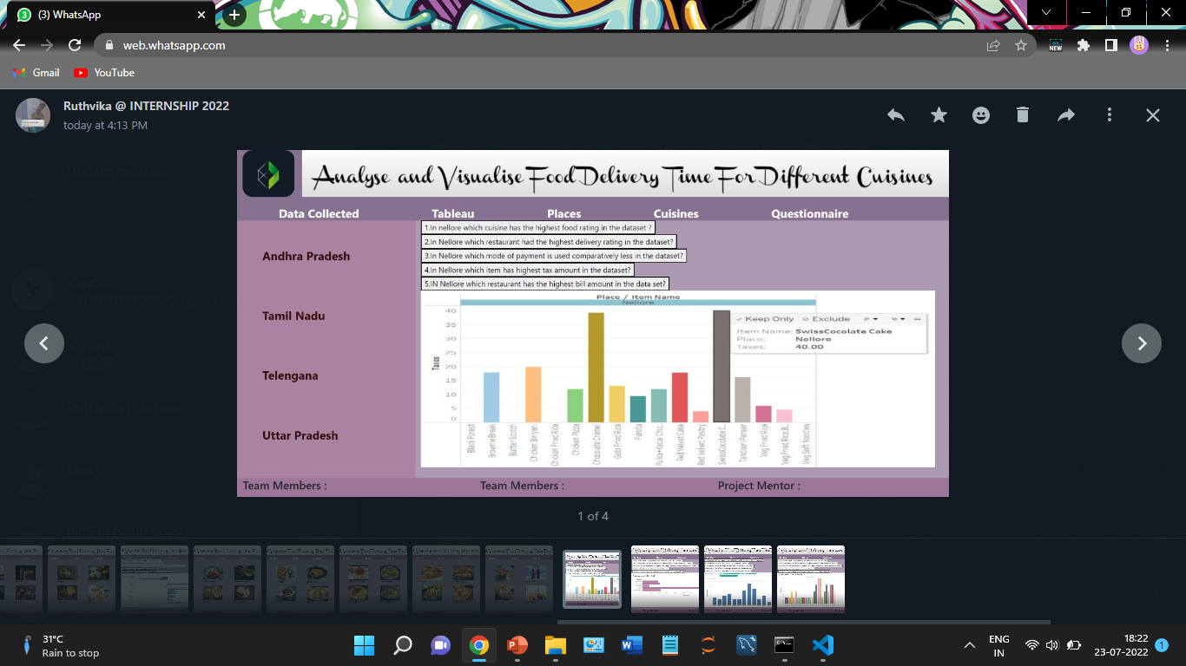

**Figure 6.2.3. – Places(Andhra Pradesh)**

**Figure 6.2.4. – Places(Tamil Nadu)**

**Figure 6.2.5. – Places(Telengana)**

**Figure 6.2.6. – Places(Uttar Pradesh)**

**Figure 6.2.7. – Cuisines(Desserts)**

**Figure 6.2.8. – Cuisines(North Indian)**

**Figure 6.2.9. – Cuisines(South Indian)**

**Figure 6.2.10. – Cuisines(Chinese)**

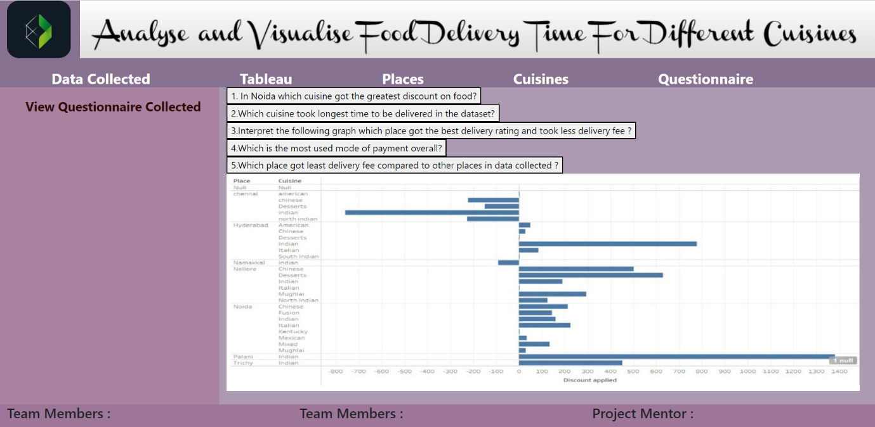

**Figure 6.2.11. – Questionnaire**

**CHAPTER-7**

**TROUBLESHOOTING PHOTO**

**CHAPTER-8**

**CONCLUSION**

This paper analyses the various characteristics of current restaurants in different localities and cities in a particular country and analyses them to predict restaurant ratings, delivery time and other queries related to food items. This makes it an important thing to take into consideration before making a dining in or online ordering decision.

It was found that a good quality of food and services depicted mostly were among the positive reviews or feedbacks from customers. An accurate prediction will help food manufacturers or other organizations to manage their customers’ behaviour towards the review of their food quality and services to give a perfect service for the customers. These strategies can help them in improving and increasing their performance and eventually make more profit.

**CHAPTER-9**

**FUTURE SCOPE**

We can implement the machine learning concepts in this project to predict the time of delivery and develop this project in the future. Machine learning is a branch of artificial intelligence (AI) and computer science which focuses on the use of data and algorithms to imitate the way that humans learn, gradually improving its accuracy.

After importing the data set, data pre-processing can be done. Data pre-processing is a process of preparing the raw data and making it suitable for a machine learning model. It is the first and crucial step while creating a machine learning model.

We can visualize the data using different types of visualization plots. To train the model we can use different types of machine learning algorithms which is useful to predict the accurate output. Each algorithm gives different accuracy rates so, we can evaluate the performance of each trained model using confusion matrix, classification report and ROC - AUC curves to determine which algorithm is best to train the model in order to predict the correct output.

**REFERENCES**

* [**https://github.com/GloriaChen0715/Food-Delivery-Time-Prediction**](https://github.com/GloriaChen0715/Food-Delivery-Time-Prediction)
* [**https://bytes.swiggy.com/the-swiggy-delivery-challenge-part-one-6a2abb4f82f6**](https://bytes.swiggy.com/the-swiggy-delivery-challenge-part-one-6a2abb4f82f6)
* [**https://github.com/chiragsamal/Predict-Food-Delivery-Time**](https://github.com/chiragsamal/Predict-Food-Delivery-Time)
* [**https://www.rishabhsoft.com/blog/optimize-food-delivery-time-with-machine-learning-analytics**](https://www.rishabhsoft.com/blog/optimize-food-delivery-time-with-machine-learning-analytics)
* [**https://www.analyticsvidhya.com/blog/2021/10/end-to-end-predictive-analysis-on-zomato/**](https://www.analyticsvidhya.com/blog/2021/10/end-to-end-predictive-analysis-on-zomato/)

**APPENDICES**

**WORKFLOW**

|  |  |  |
| --- | --- | --- |
| **DAY** | **DATE** | **TASK** |
| Day 1 | 21/06/2022 | Data collection and learning tableau |
| Day 2 | 22/06/2022 | Data Entry and learning tableau |
| Day 3 | 23/06/2022 | Learning tableau and research |
| Day 4 | 24/06/2022 | Data Entry and learning tableau |
| Day 5 | 25/06/2022 | PPT making and data entry |
| Day 6 | 27/06/2022 | PPT making |
| Day 7 | 28/06/2022 | Learning tableau |
| Day 8 | 29/06/2022 | Learning tableau |
| Day 9 | 30/06/2022 | Data Entry and normalization |
| Day 10 | 01/07/2022 | Data Entry and normalization |
| Day 11 | 02/07/2022 | Data Entry and normalization |
| Day 12 | 03/07/2022 | Framing questionnaires |
| Day 13 | 04/07/2022 | Framing questionnaires |
| Day 14 | 05/07/2022 | Creating visual representations |
| Day 15 | 06/07/2022 | Creating visual representations |
| Day 16 | 07/07/2022 | PPT making |
| Day 17 | 08/07/2022 | Web layout creation |
| Day 18 | 011/07/2022 | Web development |